
Lesson 10: Play It Again
Scratch
VIDEO GAME CREATION
This week: when the round ends, the game actually stops - and pressing R brings it back to a genuinely fresh start.
Open your own [YourName]Game project from Lesson 9 - don't start a new one.
Tip: no new assets this week - this is a logic lesson, and it reuses your very first setup code from Lesson 5.

Setup
- Open your [YourName]Game project from Lesson 9.
- Create a new variable game_active (for all sprites, not "for this sprite only"). Scratch has no true/false type, so game_active just holds the words true or false. Type them in lowercase, exactly, every time.

Level 1 - Minimal (MVP)
When the round ends (win or lose), the game freezes - score and lives stop changing, and further enemy hits/escapes do nothing. Pressing R resets everything and starts a new round.
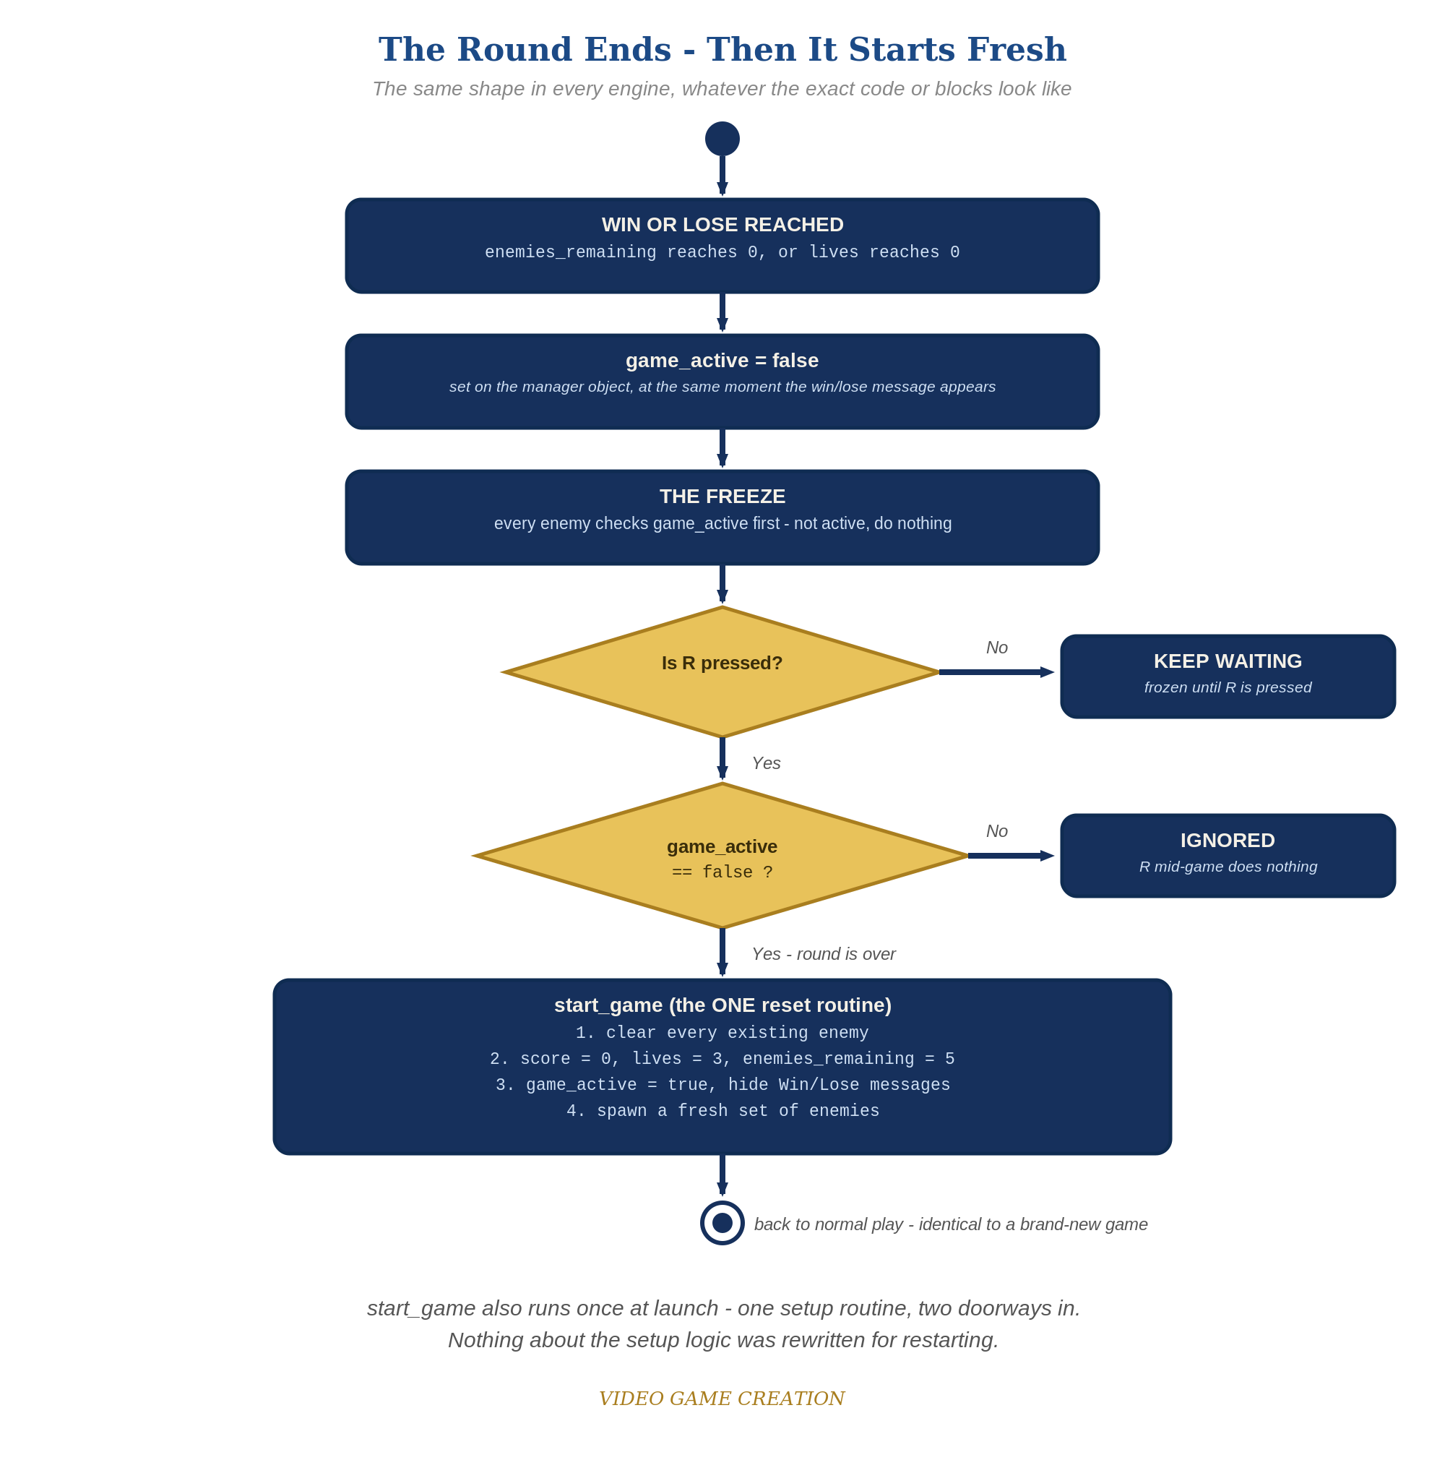
When the round ends, everything freezes - and R, pressed only while the round is over, runs the one reset routine. The same shape in every engine.
- On GameManager, change your existing "when green flag clicked" script to just: hide, then "broadcast [start game]" - a thin trigger instead of the full setup. GameManager already owns score, lives, and enemies_remaining, so the reset belongs here too.
- On GameManager, add a new script "when I receive [start game]" containing the setup the green-flag script used to do: set score to 0, set lives to 3, set enemies_remaining to 5, set game_active to true.
- On the Enemy sprite, change your existing spawn script so it starts with "when I receive [start game]" instead of the green flag, followed by your existing spawn loop (repeat 5: create clone of myself, and so on).
- Still on the Enemy sprite, add a SECOND, separate script: "when I receive [start game]" with a single "delete this clone" block under it. Clones hear broadcasts too, so on a restart every old clone deletes itself, while the original Enemy sprite (where "delete this clone" does nothing) keeps its spawn script and makes the fresh set. ("delete this clone" is an end block - nothing can connect under it - which is why it needs its own script.)
- In the Enemy's "when I start as a clone" forever loop, add an "if game_active = false then" block at the very top, with a "stop this script" block inside it (code below). When the round ends each clone stops running its movement, hit and escape checks and freezes where it is; the fresh round deletes it.
- On GameManager's "when I receive [enemy hit]" script, add "set game_active to false" right before "broadcast [you win]". On its "when I receive [enemy escaped]" script, add "set game_active to false" right before "broadcast [game over]". The Enemy sprite itself never touches game_active - it still only reports what happened.
- Update the Player's win/lose "say" blocks to include the restart hint: "say [You Win! Press R to Restart] for 3 seconds" and "say [Game Over - Press R to Restart] for 3 seconds".
- On GameManager, add a new script: "when key r pressed -> if game_active = false then broadcast [start game]".
- Click the stage, play to a win or loss, confirm the game freezes, then press R and confirm everything resets and play resumes.
Highlighted lines are new this week; everything else is code you already have.
// GameManager (hidden sprite):
when green flag clicked
hide
broadcast [start game]
when I receive [start game]
set score to 0
set lives to 3
set enemies_remaining to 5
set game_active to true
when I receive [enemy hit]
change enemies_remaining by -1
change score by 10
if enemies_remaining = 0 then
set game_active to false
broadcast [you win]
when I receive [enemy escaped]
change lives by -1
if lives = 0 then
set game_active to false
broadcast [game over]
when key r pressed
if game_active = false then
broadcast [start game]
// Enemy sprite:
when I receive [start game]
repeat 5
create clone of myself
// (your existing position and wait blocks stay here)
when I receive [start game]
delete this clone
when I start as a clone
forever
if game_active = false then
stop this script
// (your existing movement blocks stay here)
if touching Bullet? then
// (your existing hit logic stays here)
if y position < -170 then
// (your existing escape logic stays here)
// Player sprite:
when I receive [you win]
say [You Win! Press R to Restart] for 3 seconds
when I receive [game over]
say [Game Over - Press R to Restart] for 3 seconds

Before You Test: Audit Your Game State
Game state is everything your game remembers right now: score, lives, positions, costumes and colors, animations, sounds, and messages on screen. Until this lesson, your game started once and ended once, so nothing ever had to be put back. A restart means ALL of it must go back to how it was at the start - including anything extra you added that this handout doesn't mention.
- Find EVERY "when green flag clicked" script: on the Stage, on every sprite, and on the GameManager. Click each sprite in the sprite list and check. Any that set up your game (position, costume, size, show/hide, variables, backdrop) must also run on "when I receive [start game]", or be moved there.
- Look at your game-over scripts ("when I receive [you win]" and "when I receive [game over]") and anything else you added that runs when the round ends: animations, costume changes, color or ghost effects, size changes, sounds, moved or hidden sprites, backdrop switches.
- For each of those, add the opposite to "when I receive [start game]": switch back to the starting costume, "clear graphic effects", set size, "go to" the starting position, show or hide, stop sounds.
- Check clones and timers too: the Enemy sprite's "delete this clone" at the start of "when I receive [start game]" clears the enemy clones, but anything else you created (extra clones, "reset timer") needs its own reset.
Rule of thumb: if it changed when the round ended (or at any point during play), something has to change it back when the round restarts.

Level 2 - Complete (Alpha/Beta)
A restart is a genuinely clean slate - no leftover enemies, no stale score/lives, and it works correctly no matter how many times in a row you play.
- Play to a win or loss, confirm the enemies freeze where they are, then press R and confirm score/lives/enemies_remaining are exactly back to 0/3/5 with no leftover clones and a fresh set of five.
- Repeat for a loss - same clean reset.
- Press R while the game is still active (mid-round) and confirm NOTHING happens - the game_active check in your restart script is what prevents an accidental reset.

Level 3 - Refined (Ready to Publish) - pick any that interest you
- Fix a real bug! We laid the groundwork for this bug all the way back in Lesson 6 when we defined our win scenario. Then in Lesson 8 we defined our lose scenario. By thinking in terms of win and lose separately, rather than in terms of wave over and game over, we created a bug. Find it and resolve it in the manner you, the Designer, think best. (Hint: play a round where you destroy some enemies and let the others escape, and watch what happens to the round, and to your R key.)
- Visual: add a brief visual cue when the game freezes, like a costume change or a "change color effect" pulse on the Player, separate from the win/lose message itself.
- Structure: notice "when I receive [start game]" is now the single place that sets up a fresh game - used both at the very first green-flag click and every restart. No setup code is duplicated anywhere in your project.

If Something's Wrong
- Restart does nothing when you press R: confirm the check is "if game_active = false" (not = true), and that game_active is actually being set to false on GameManager at the moment of the win or loss.
- Restart leaves old enemies on screen or doubles them: confirm the Enemy sprite has a separate "when I receive [start game]" script containing "delete this clone". It cannot go inside the spawn script, because it is an end block and nothing can follow it.
- Enemies keep moving after game over: confirm the "if game_active = false then stop this script" block is the very FIRST block inside the clone's forever loop, above all the movement, touching-Bullet and escape blocks.
- Pressing R mid-game causes chaos: confirm GameManager's "when key r pressed" script checks game_active before broadcasting - without that check, R would restart the game at any moment.

Want More?
Student Resource List > Scratch section, or scratch.mit.edu/ideas

